PROBLEMS FACING LOCAL MONEY TRANSFERS IN SOUTH SUDAN: CASE STUDY OF LOCAL MONEY TRANSFERS IN GOK STATE-CUEIBET

BY
ANDREA MAJOTH KACHUOL

A RESEARCH PROPOSAL SUBMITTED IN PARTIAL FULFILLMENT OF THE REQUIREMENT FOR THE AWARD OF DIPLOMA IN FINANCE MANAGEMENT FOR NGOs TO THE STRATEGIA NETHERLANDS

November 30th 2019
Well laid out cover page

DECLARATION
Declaration by the Student
This research proposal is my original work and has not been presented to any other examination body. No part of this research should be reproduced without my consent or that of the Strategia Netherlands.

Name: _____________________Signature: _________________ Date____________
D008/2018/2019

Declaration of the Supervisor.
This research project has been submitted for defense with my approval as the Strategia Netherlands, Supervisor.

Name: _____________________Signature: _________________ Date____________
Supervisor
DEDICATION
I faithfully dedicate this research proposal to both Mott Macdonald & Water for Lakes for their encouragement; financial support and updates that they could give throughout every stage of my study. God’s protection for them shall endure forever. Secondly I dedicate it again to my beloved fiancée Sarah Akol and my mother Nyichol Ater Dhieu, all shall see the kingdom of God

Great presentation

ACKNOWLEDGEMENT
I joyously acknowledge God the almighty for the gift of grace and ability he has given me to fully concentrate in my studies and for his divine wisdom that he gave me to carry on this research throughout this study. I am duly and sincerely indebted to my supervisor Mr. Fredrick Ratemo for his positive attitudes and quick response to enable me to come up with this beautiful piece of work.
I also thank Green Village Network GVN for having employed me as without GVN I would have not got this an opportunity. Finally, thank again to Mott Macdonald, Water for Lakes, Green Village Network and Strategia Netherlands, all shall be remembered in heart in that series

ABSTRACT
The purpose of this research proposal was to establish the essence of book keeping and proper record keeping in all local money transfers in South Sudan case study of Gok state-Cueibet. Here questionnaire were designed and distributed to all local money transfers to be filled and face to face interview to some extend

TABLE OF CONTENT
DECLARATION………………………...……. ii
DEDICATION iii
ACKNOWLEDGEMENT iv
ABSTRACT v
TABLE OF CONTENTS vi
ABBREVIATIONS vii
OPERATIONAL DEFINITION OF TERMS viii

CHAPTER ONE
INTRODUCTION OF THE STUDY
1.1 Introduction 1
1.2 Background of the Study 1
1.3 Statement of the Problem 3
1.4 Objectives of the Study 4
1.5 Research Questions 5
1.6 Significance of the Study 5
1.7 Limitations of the Study 5
1.8 Scope of the Study 6

CHAPTER TWO
LITERATURE REVIEW
2.1 Introduction 7
2.2 Review of Theoretical Literature 7
2.3 Review of Analytical 21
2.4 Summary 23
2.5 Conceptual Framework 24

CHAPTER THREE
RESEARCH DESIGN AND METHODOLOGY
3.1 Introduction 26
3.2 Study Design 26
3.3 Target Population 26
3.4 Sample Design 27
3.5 Data Collection Procedures 27
3.6 Data Analysis Methods 29
CHAPTER FOUR
DATA, ANALYSIS, PRESENTATION AND INTERPRESENTATION OF FINDINGS
4.1 Introduction …...30
4.2 Presentation of Findings …......30
4.3 Summary of Data Analysis …...46

CHAPTER FIVE
SUMMARY OF FINDINDGS, CONCLUSION AND RECOMMENDATIONS
5.1 Introduction …...48
5.2 Summary of the Study Findings …...48
5.3 Conclusion …...49
5.4 Recommendations …...49
5.5 Suggestion for Further Study …...50
REFERENCES 51

APPENDICES
Appendix I Questionnaire

LIST OF ABBREVIATIONS
FAM Finance and Accounts Manager
CAO Chief Accounting Officer
AR Accounts Receivable
LMT Local Money Transfer
IA Internal Auditor
BM Branch Manager

OPERATIONAL DEFINITION OF TERMS
Finance the way in which money is used and handled especially the way in which large amounts of money are used by companies and governments. In other words the system that includes the circulation of money, the granting of credit, the making of investments and provision of banking facilities
Management is the act or skill of controlling and making decisions about a business, department, company, and sports team. The act or process of deciding on how to use something.
NGO stands for Non-Governmental Organization this a company, business, club that is formed for a particular purpose. It is the act or a process of putting the different parts of something in a certain order so that they can be found or used easily.

CHAPTER ONE

INTRODUCTION OF THE STUDY

1.1 Introduction
The chapter presents overview, the background of the study, statement of the problem, objectives of the study, research questions, significance, limitations and the scope of the study. This brings about good understanding of what the study is expected to attain in the long run.
1.2 Background of the study
Finance the way in which money is used and handled especially the way in which large amounts of money are used by companies and governments. In other words the system that includes the circulation of money, the granting of credit, the making of investments and provision of banking facilities
Management is the act or skill of controlling and making decisions about a business, department, company, and sports team. The act or process of deciding on how to use something.
NGO stands for Non-Governmental Organization this a company, business, club that is formed for a particular purpose. It is the act or a process of putting the different parts of something in a certain order so that they can be found or used easily.
Therefore, proper records keeping and transfer of money is an essential method that any local money transfer operating in South Sudan of case study Gok state-Cueibet.
Additionally, welfare of staff as the study found to be one of the major problems facing local money transfer or general transfer in South Sudan. South
Sudan as one the developing countries is today struggling to cope with economic crisis that had hit the country since 2013 up to date. Against this background, the central bank of South Sudan has been trying its best to devalue US dollar against pound in order to stabilize its economic crisis such as increased in dollar rate.
The main benefits of money transfer are linked to its effectiveness, as it is a quick, easy and
cheap way of transferring money. Benefits of money transfer as a delivery mechanism include: (i)
increased effectiveness management; (ii) increased cost efficiency; (iii) improved safety and protection of
Beneficiaries or shareholders and funds; (iv) quick return in investment; and (v) general transaction of cash.
According to the surveyed population, the top benefits of utilizing money transfer to deliver
cash transfers relate to logistical advantages, and increased freedom and personal safety of
shareholders. Sixty-seven percent of the population identified having to travel less to get assistance as
a major benefit, while 62 percent thought that the use of money transfer services for cash-based
transfers would carry fewer restrictions and a greater freedom to spend the money as preferred, which
could enhance their dignity. Fifty-four percent reported increased funds safety as a key benefit, and
45 percent reported security of the money received as important benefit, both of which were more
strongly felt by rural residents. Furthermore, for a quarter of the sample, the fact that it does not need
to be cashed out and can instead be used to perform digital financial transactions was also attractive.
Further, beneficiaries of humanitarian assistance are significantly more likely to identify certain
benefits of using money transfer – faster delivery of support, confidentiality of the amount received,
the option to keep the money on the account – compared to non-beneficiaries.
In addition to cash-transfer, the general population of South Sudan can also
benefit from the introduction of money transfer. In particular, money transfer can i) ease financial
transactions, ii) increase safety of people and of money, and iii) build confidence. This is well evidenced
in other countries in East Africa, such as Somalia. Research on the Mobile Money Ecosystem in
Somalia commissioned by the World Bank highlighted that Somalis associated mobile money with
eased transactions; gains in time and money; and increased resilience, as remittances and financial
help from friends and relatives could be easily received in the event of a shock. To a lesser extent, they also associated mobile money with a lower risk of theft and improved personal security as it eliminates
the need to carry cash.49
Nonetheless, the general population does not seem to associate money transfer with better
economic well-being or access to services. Even though 75 percent of potential customers were willing
to take up saving services once money transfer is available, only 17 percent of respondents felt that this
represents a benefit in terms of expanded saving possibilities for livelihood opportunities. Instead, the
benefit of increased local money transfers to shocks as a result of faster transfers from friends, relatives and
humanitarian organizations was mentioned by 28 percent of the surveyed population. The two least
mentioned benefits were better access to basic services (i.e. health, education) and to new
opportunities (i.e. new skills, jobs), and increased social connectivity to community members, each
reported by 15 percent of respondents.
Long term benefits stemming from money transfer, are likely underestimated due to lack of
exposure to services. Notably, money transfer has proven to increase access to financial serveices in other
neighboring and remote areas of South Sudan. For instance, it played a great role during this entire crisis that hit South Sudan as it
facilitated delivery of financial support from friends, relatives, and humanitarian and development partners. In
fact, 60 percent of South Sudan who were affected by the crisis considered that money transfer helped
them, or could have helped them, to be less acutely affected by the crisis.

Promoting financial inclusion to the unbanked population could be another benefit
stemming from the introduction of money transfer in South Sudan. In Somalia, 85 percent of mobile
money users stated that mobile money has fostered their financial inclusion. Examples from Kenya
show that M-PESA has increased financial inclusion for the most vulnerable groups, such as women,
as they are able to have personal savings without seeking permission from their husbands, and for
farmers, as they are able to access insurance services which rely on the Safaricom platform.
Research indicates that money transfer could have a strong potential to foster financial
inclusion in South Sudan. Three quarters of the population thought that money transfer could help
increase financial inclusion, by making it easier to perform financial transactions within South Sudan
(75 percent), by financially connecting money transfer customers to other states (49 percent) and by helping customers access other financial services, e.g., savings, loans or banking (for 41 percent).
Literacy is significantly positively correlated with the perception that money transfer could increase
financial inclusion through the variety of channels listed above.
Perception of money transfer as fostering financial inclusion is positively correlated with prior
exposure to transfer money services. Current users of foreign money transfer like save trust in Gok state services are significantly
more inclined to believe that money transfer would help increase financial inclusion. In fact, only 12
percent say that it would not make them feel more financially included

    - Profile of all local money transfers in South Sudan (Gok state-Cueibet)

Most of local money transfers in South Sudan of case study Gok-Cueibet are privately owned. They are owned by the shareholders who invested their money with aim of making of profit. Some local money transfers in South Sudan are closed down due to 2013 country political crisis in Gok state for example Mac local money transfer, Luiku, Loibai etc are closed down due to mismanagement and looting of money in the head offices in Juba due to the said problem above

1.3 Statement of the Problem

Proper record keeping and well management of finances do not on their own necessarily lead to safety of funds but also quick return in investment. There is now vivid evidence showing the essence of principles of account, in particular money measurement or double entry concepts:
The study identified the importance of book keeping and management skills as can be seen in some local money transfers such as Wathok, Elephant and Mayo in local money transfer respectively
It is also true that without principles of account in place, there would be no records keeping.

1.4 Objectives of the Study

1.4.1 General Objective
The main objective of the study was to determine the problems facing local money transfers in South Sudan case study of Gok state-Cueibet
1.4.2 Specific Objectives
- To evaluate the problems facing local banks in South Sudan of Gok stat-Cueibet.
- To find out the effects of fraud in local money transfers South Sudan case study Gok state- Cueibet.
- To determine the problems facing managers of local money transfers South Sudan Gok state-Cueibet.
- To determine how the local money transfers operate in South Sudan Gok state-Cueibet.

1.5 Research Questions
- What are the causes of fraud in local money transfers in South Sudan Gok state?
What are problems facing managers of local money transfer South Sudan Gok state?
- What is the effect of poor management in local money transfers South Sudan Gok state?
- To determine the system used to record money in local money transfers in South Sudan Gok state-Cueibet?
s

1.6 Significance of the Study

1.6.1 Local money transfers in South Sudan case study Gok State-Cueibet
The local money transfers in South Sudan Gok state are likely to benefit from this study by gaining insights concerning the relationship between importance of proper record keeping and the factors influencing it.

1.6.2 Researchers
Researchers who are conducting related study may use this research as their secondary data. The research will also propose other areas which the researcher can explore further. They can also do another research in the same way to weight the trend further.

1.7 Limitation of the Study

1.7.1 Confidentiality
Confidentiality was a major point of concern as some respondents reluctant in giving details to someone they consider not familiar, thinking that the researcher would use the information to their competitive advantage or report it to their top management . The researcher overcame this challenge by first contacting the top management on phone in Juba head offices before distributing the questionnaires. This assured them the purpose of the study.

1.7.1 Uncooperative Respondents

The study encountered poor cooperation from respondents. Moreover, the respondents restricted themselves to the responsibilities and duties. This lead the researcher to be ignored when enquiring and acquiring relevant information, however, the researcher informed the respondents on the importance of the study and cited the top beneficiaries.

1.8 Scope of the study
The study was carried out within Cueibet town and some other counties such as Malou-Pec, Mayath and Abiriu counties. The main aim was to know the problems facing local money transfers in South Sudan case study Gok state-Cueibet. The departments under study included top management, Shareholders, auditors, Tellers, middle and support staff management of all local banks. The study was undertaken within a period of one month of November 2019.

CHAPTER TWO
LITERATURE REVIEW
2.1 Introduction
The review is an important part of the objective approach to research in all fields of enquiry. This is aimed at identifying the research gaps to the existing literature and emphasizing on the need to carry out this study which is concerned with examining the problems facing local money transfers in South Sudan case study Gok state-Cueibet. The purpose of this literature review is to provide the researcher with means of getting to the frontiers of knowledge of the issue under investigation. To this end, the present chapter covers a review of theoretical literature review of analytical literature of analysis and gaps to be filled, a summary of the chapter and the conceptual framework.
2.2 Review of Theoretical Literature
2.2.1 Finance Saving
Pandey (2005), found that the aim of any business is to make profit for its owners. The size of profit made will largely depend on how efficiency the capital or assets are used. By looking at financial facts and figures of a firm one is able to get an idea as to the ‘healthiness’ of it and how efficiently the asset is being used.
Girtman (2006), commerce for East African, found that finance forms a link in the commerce chain. It belongs to that class of links that was established as very important. These are the links that provide additional money capital for business man to expand their business activities. Like the entire link in this class. Its important lies in the fact that it makes possible the movement of a larger quantity of goods along the business. Finance can be defined as are an art and the science of managing money. Finance is also money needed by firm in its activity, which then generates returns and helps to maximize a shareholders wealth. Also states that finance is the lifeblood of any venture. Any firm no matter how big or small makes on cash and not profits. You cannot pay bills with profits only with cash.
Finance, according to William (2002), is the function in a business that acquired funds for the firm and managers these funds within the firm. Like our personnel needs the capital needs of a business change over time. Virtually all organizations have certain operational needs for which funds must be available. The key areas include managing day by day needs of the business. Controlling credit operation, acquired needed inventory and making capital expenditure. Finance is key to be formulation and implementation of tactical plans that an organization has. This is because finance is key to all other resources. Thus finance meant for tactical plans in the beer manufacturing industry must be managed with case transparency and proper accountability to ensure better achievement of organizational goals and objectives.
Business finance is concerned with the whole problem of funding capital necessary to run a business. It includes money required for the purchase of all permanent assets of the firm as well as the amount required for day to day operation. A sound business finance system incorporates security long term and short term finance system incorporates securing long term and short term finance is running the business, calculating the gross and net profit and also investing the profit and also investigating in those profits allocation of the variable finance into the various business activities and investigate in the assets recording the assets and liabilities of the business into a balance sheet (Gichire, 1991).
According to Hirsh (2007), the view of any new venture is stated with personal family and friends’ contribution attributes by their relatively good relationships. Another source of short term funds is commercial banks and they are most frequent used by the entrepreneur when this is available collateral. The funds provided are in the form of debts financing and as such they require some assets with value the collateral can be in form of business asset such as land, car, equipment bonds or stocks.
According to Todegado (1992), finance is the provision of money when it is required. Finance is the lifeblood of an enterprise. There are a number of factors why small enterprise have particular difficult in obtaining formal credit or find the cost not working the effort. Small processing and training enterprise are frequently unable to provide the collateral required by the credit organization. Since most are assets poor and unable to use as collateral land held under traditional land tenure system. The requirement for collateral is itself a product of the risk, real or perceived and high transaction cost of bank loan may be very high relative to the actual size of the loan.
According to Jaffe and Morton (1995), assets that financial system in the sub Sahara Africa have traditionally been characterized by weak resource mobilization, low credit rate, high transaction cost and extensive political interference which has impeded the participating institution to return the needed service to promote various industries and sector.
Profitable operation is the prime goal of any business and is often the only result that justifies continued existence of most business however, over emphasizing profit could be misguide management and pose a threat to continuation of cash business hence, provision must be made for financial goals such as; service to the society betterment of employee and efficiently use management finance, machines, men, materials and methods, financial management is that activity concerned with ensuring that organizations financial resources are obtained and used profitably and effectively in the process of accomplishing the objectives of the organization. It is the activity concerned with planning, raising, controlling and administration of fund in business (Sagimo, 2002).
According to Otieno (2002), finance is important in the overall development process and one of the major factors of productivity together with the land and labor. In the same vein, it is one of the key inputs in the development and the growth of development enterprise. Furthermore in a business system one of the reasons firm form linkages and relationship with one another is for the purpose of access of financial capital. It is likewise, the cue that the overall process of development, function market in particular services the broad purpose of mobilization on surplus resource or serving from saver, and their broad allocation to investors/borrowers, in the form of credit through the transaction taking place in the organizational financial system.
Consciously the financial system is therefore made up of institutions for saving or borrowing, whose basic component are the financial rules of the engagement in the exchange of goods and services for consumption and investment and financial organizations formal and informal investment and social economic political objectives(Otieno, 2012).
Access to financial can be constraining to economic activity. These result from a number of factors. Some of which are institutional. The existence of interest group with political influence may lead to a credit allocation system where by many firms with variable projects are left out while others get credit on favorable term. Where the legal institutional framework for enforcement of financial contracts is weak, the consequence is that the leaders have either to rely on self-enforcement mechanism of not give loan (Otieno, 2012).
2.2.2 Cost reduction & control
Cost reduction is the process used by companies to reduce their costs and increase their profits. Depending on a company’s services or product, the strategies can vary. Every decision in the product development process affects cost.
Cost control essentially involves the setting of targets for cost centre managers and then monitoring performance against those targets.
A cost control systems entails six requirements:
- effective delegation of authority and assignment of responsibility for costs
- an agreed plan that sets up clearly defined and agreed goals
- motivation to encourage individuals to reach the goals established and agreed
- timely reporting with alternative suggestions how to reduce costs
- recommendations and action which must be followed
- effective follow-up system to ensure that corrective measures are being effectively implemented
Examples of cost control techniques: - budgetary control, standard costing and control of capital expenditure.

Cost reduction
Cost reduction is the reduction in unit cost of goods or services without impairing suitability for the use intended,
i.e. without reducing value to the customer.
Hence, it looks at methods of improving profitability by reducing costs without necessarily increasing prices.

2.3 Review of Critical Literature
From the studies evaluated there have been gaps which have been left by the previous researchers, which need to be filled on the issue of finance, and cost reduction. Although the authors come up with different problems facing local money transfers in general, it was clear that they did not indicate how the problems affect local money transfers. The study did not major on the central bank policy, which could be of great importance in the improvement of the same in the whole country. Study was carried out to fill the gap on how problems facing local money transfers should be addressed.
Finance is usually the major constraint in any business set up. Where finance is easily available, it usually makes it possible for the organization to purchase, pay bills and also enable the organization to conduct their activities with ease. Pandey (2005), it also determines the performance of any organization. Without finance, the tactical level manger cannot implement the changes and need of an organization effectively.
Cost reduction provides guidelines that ensure the smooth operations of a business. The guidelines can at times hinder or improve the implementation of tactical plans thereby becoming a challenge in the tactical level operations. It is easier to achieve an organizational goal where the policies are favorable vice versa (Sherman, 1989). However the study has failed to show us how Cost reduction affects local banks. And therefore the study was conducted to fill those gaps of the previous researchers.
2.4 Summary of Gaps to be filled
The study therefore aimed at filling the gaps identified in previous study by investigating every concept through to be creating problems, while explaining the problems facing local money transfers in South Sudan
The financial saving hitch in the organization may be alleviated by outsourcing some of the company’s co activity like transport services to reduce on staff and staff related cost, Vehicle maintenance cost etc.
Cost reduction provides guidelines that ensure the smooth operations of a business. The guidelines help to reduce the running cost and save on resources that are used to transfer money across the country.
2.5 Conceptual Framework
This section prospects a schematic interpretation of the conceptual framework as shown in the figure below.
Figure 2.1 Conceptual Framework
Independent variables Dependent Variables
Finance Saving
Cost reduction and control
Problems facing local money transfers in South Sudan
Proper records keeping
Management style

Source: Author (2013)
2.5.1 Finance Saving
Finance is the amount of money that is available in the organization which makes it able to buy and to carry out organizational activities with ease and that which makes the organization activities to run smoothly. In every organization finance is the key to implementation of all policies. Finance is concerned with the process of raising capital from financial markets and covers subject such as the operation of market for short and long term finance. Many of the tactical management level in business companies are faced with lack of finances due to scarce implementation of tactical plans that could see the organization maximize its profit and increase sales.

2.5.2 Cost Reduction and Control
Cost reduction is the process used by companies to reduce their costs and increase their profits. Depending on a company’s services or product, the strategies can vary. Every decision in the product development process affects cost.

CHAPTER THREE
RESEARCH DESIGN AND METHODOLOGY
3.1 Introduction
This chapter presents description of the research methodology that shall be used to answer questions described in chapter one of this research study. The methodology to be used in the research study includes research design, target population, sampling design and data collection and analysis procedures.

3.2 Research Design
The study used descriptive research design when conducting the study. Descriptive research was used to obtain information concerning the current status of the phenomena to describe "what exists" with respect to variables or conditions in The local banks of Gok state situation. This method involved range from the survey which describes the status quo, the correlation study which investigates the relationship between variables. Descriptive studies are not only restricted to fact finding but may often result in the formation of important principles of knowledge and solution to significant problems. They are more than just a collection of data since they involve measurement, classification, analysis and interpretation (David, 2005).
3.3 Target Population
Schindlers (2003), described the target population as the complete set of individual’s area of objects with some common characteristics to which the researcher wants to generalize the result of the study. According to Kothari (2004), target population is a universal set of the study of all members of real or hypothetical set of people, events or objects to which an investigator wishes to generalize the result. In this case the target population was 54 local money transfers operating in Gok state with 64 employees where it comprised levels of management as of the top, middle and support staff levels of management.

Table 3.1 Target Population
Category | Frequency | Percentage
Top Level Management | 9 | 18
Middle Level Management | 21 | 38
Support Staff Management | 24 | 44
Total | 54 | 100
Source: Author (2019)

3.4 Sample Design
A sample is a representative of population. The sampling technique adopted was stratified random sampling method. It was used since it is reviewed to be free from biasness of population; it considered all levels of population. A sample size of 32 respondents was drawn representing 50% of the target population.

Table 3.2 Sampling Design
Category | Target Population | Sample Size 50% | Percentage
Top Level Management | 9 | 6 | 18
Middle Level Management | 21 | 10 | 31
Support Staff Management | 24 | 16 | 51
Total | 54 | 32 | 100
Source: Author (2019)

3.5 Data Collection Instruments and Procedure
For the purpose of the study, questionnaires and secondary data were used to collect the data. The questionnaires were structured in such a way that it obtained both qualitative and quantitative data.

3.5.1 Primary Data
This is a list of questions that are sent to a number of persons seeking their responses that can be tabulated and treated statistically. It is a form for securing answers to questions from respondents. The researcher used both structured and unstructured questionnaire which have both structured and semi-structured questions. There was a pre-determined question whereby respondents were served with the questionnaire and are given a chance to fill. The types of questions used were both open and closed ended. Closed ended questions were used to ensure that the given answers were relevant. The researcher phrased questions clearly in order to make dimensions along which respondents were analyzed. In open-ended questions, space shall be provided by the respondent, thus giving him/her freedom to express their feeling.

3.5.2 Secondary Data
Materials available in the company, books available in the library in relation to this study, magazines, newspapers, journals and www (World Wide Web) were used.

3.5.3 Validity and Reliability of Research Instruments
Kothari (2004), states that validity is the accuracy and meaningfulness of inferences which are based on the research results. It is the degree through which results obtained from the analysis of data represent the phenomenon under study while reliability is a measure of the degree to which a research instrument yields consistent results after repeated trials. It involved administering the same instrument a number of times to the same group of subject.
The research obtained authority from relevant departmental sections of the banks to circulate questionnaires. To ensure reliability and validity questionnaires were pre-tested on five respondents. These respondents were included in the final study. The questionnaires were then corrected before the final distribution is done.
3.5.4 Administration of Questionnaires
Questionnaires were used in the study which was hand-delivered and collected after a few days. The types of questions to be used included both open and closed ended. Closed ended questions were used to ensure that the given answers are relevant. The research phrased the questions clearly in order to make clear dimensions along which respondents will be analyzed. In open ended questions, space was provided for relevant explanation by the respondents, thus giving them freedom to express their feelings. This method was considered effective to the study in that; it created confidentiality. The presence of the researcher was required as the questionnaire was self-administered.

3.6 Data Analysis Methods
According to Kothari (2004), data analysis procedure includes the process of packaging the collected information putting in order and structuring its main components in a way that the findings can be easily and effectively communicated. After the fieldwork, before analysis, all questionnaires were adequately checked for reliability and verification. Editing, coding and tabulation were carried out. The data collected will be analyzed using simple qualitative and quantitative methods and presented using tables, figures and charts.

CHAPTER FOUR
DATA ANALYSIS, PRESENTATION AND INTERPRETATION OF FINDINGS
4.1 Introduction
This chapter undertook to analyze and discuss the data collected from the respondents in relation to research objectives and questions. Analysis was presented using frequency tables and percentages, presented in graphs charts and interpreted thereafter. The open ended questions were analyzed in qualitative nature and closed ended questions analyzed in quantitative nature.

4.2 Presentation of Findings
4.2.1 Response Analysis
Table 4.1 Response Analysis
Respondents Category | Frequency | Percentage
Response | 40 | 85
Non-response | 14 | 15
Total | 54 | 100
Source: Author (2019)
Figure 4.1 Response Analysis
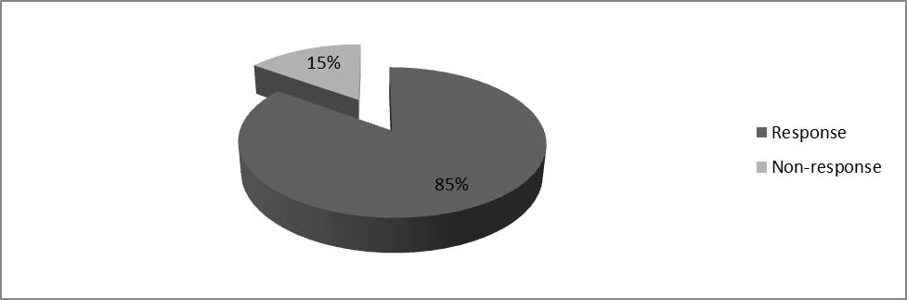Source: Author (2019)
Table 4.1 and figure 4.1 above indicate the respondents who were given the questionnaires, 85% of the total respondents duly filled and returned the questionnaires for analysis while 15% did not respond neither did they return their questionnaires and therefore were not analyzed. This indicated that the organization had a high percentage of employees who actively participated in the research study.

4.2.2 Gender Response
Table 4.2 Gender Response
Gender | Frequency | Percentage
Male | 34 | 62
Female | 20 | 38
Total | 54 | 100
Source: Author (2019)

Figure 4.2 Gender Response
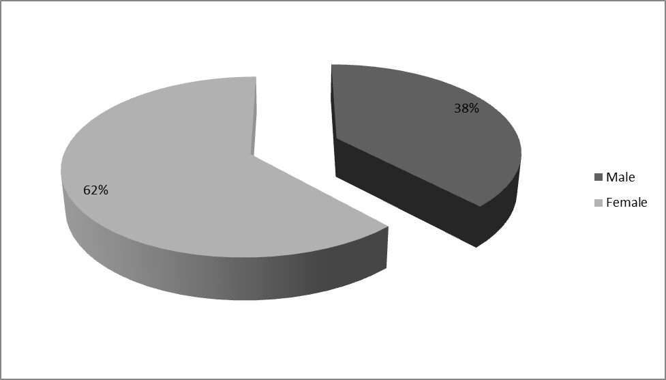Source: Author (2019)
The table 4.2 and the figure 4.2 indicate the response on gender. The analysis clearly shows that the organization had a higher number of females compared to males. The female were represented by 62% respondents while the males being the minority were represented by 38% of the total respondents. This implies that the 1/3 gender rule was met by the organization.

4.2.3 Age Bracket
Table 4.3 Age Bracket
Age Bracket | Frequency | Percentage
18 – 25 years | 5 | 10
26 – 35 years | 15 | 27
36 – 45 years | 25 | 46
46 – 55 years | 5 | 10
56 years and above | 4 | 7
Total | 54 | 100
Source: Author (2019)
Figure 4.3 Age Bracket

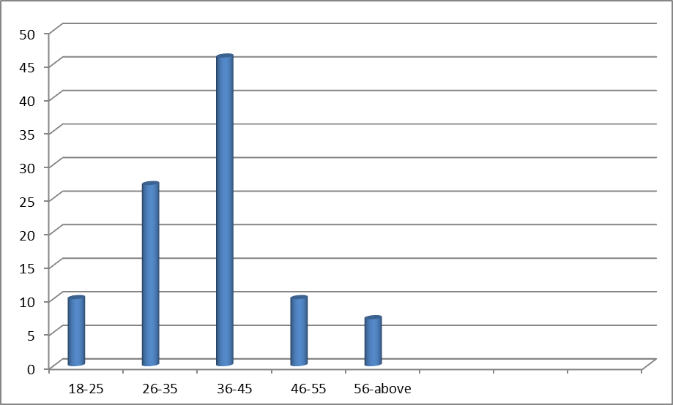

Source: Author (2019)
According to table 4.3 and figure 4.3 above, indicates the ages of the respondents analyzed. Form the analysis 46% of the total respondents being the majority were ages between 36-45 years, 26-35 years were represented by 27%, 46-55 years were 10% while those between 18-25, and 56 years and above were 10% and 7% respectively. From the above study it can be deduced that the majority of the respondents were between the ages of 36-45 years, young and energetic to work.

4.2.4 Highest Level of Education
Table 4.4 Highest Level of Education
Category | Frequency | Percentage
Primary | 6 | 11
Secondary | 36 | 67
College | 5 | 9
University | 4 | 8
Post Graduate | 3 | 5
Total | 54 | 100
Source: Author (2019)

Figure Highest Level of Education

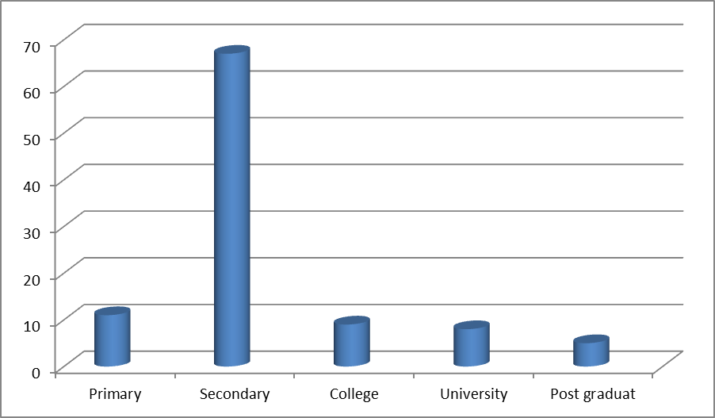

Source: Author (2019)
The above table 4.4 and figure 4.4 indicate the response on the highest education level. The response from primary level was 11%, secondary level was 67% being the majority while the response of college level was 9% bei, 8% were from university level and those who had post graduate qualification were 4%. From the analysis therefore it can be concluded that majority of the respondents had secondary qualification indicating high level of illiteracy at the companies.

4.2.5 Duration of Working in local money transfers
Table 4.5 Duration of Service
Duration of Service | Frequency | Percentage
2 years and below | 6 | 11
3-5 years | 30 | 56
6-8 years | 10 | 18
9-11 years | 6 | 11
12 years and above | 2 | 4
Total | 54 | 100
Source: Author (2019)
Figure 4.5 Duration of Service
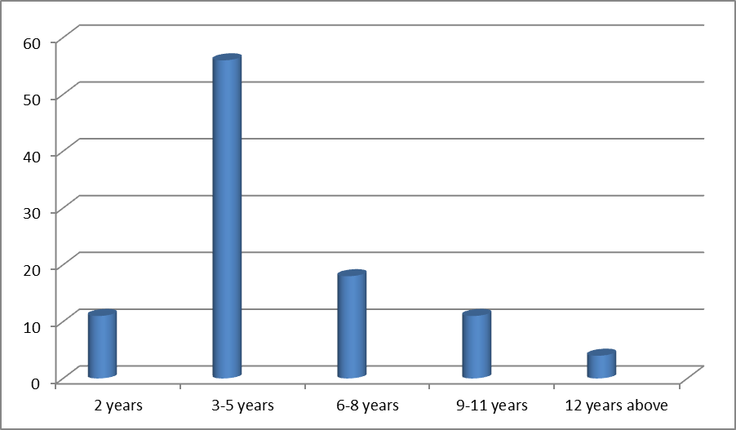

Source: Author (2019)
The above table 4.4 and the figure 4.4 indicate the duration of service to which the respondents have served in the organization. From the analysis 11% indicated that they have worked in the organization for less than 2years, 56% said that they have served for 3-5years while 6-8years, 9-11 years and 12 years and were represented 18%, 11% and 4% respectively. From the analysis majority of the respondents had good experience.

4.2.6 Respondent Category
Table 4.6 Respondent Category
Respondent Category | Frequency | Percentage
Top Level Management | 10 | 18
Middle Level Management | 19 | 36
Support Staff Management | 25 | 46
Total | 54 | 100
Source: Author (2019)

Figure 4.6 Respondent Category

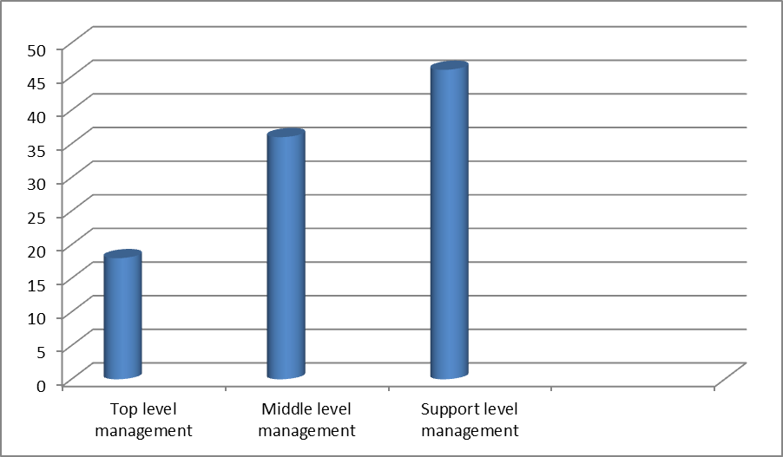

Source: Author (2019)
According to table 4.6 and figure 4.6 above shows the category of respondents in the organization. From the analysis 18% of the total respondents were top management 36% were form supervisory management while the remaining 46% were from the support staff level of management. Based on the study findings it can be concluded that majority of the respondents were support staff.
CHAPTER FIVE
SUMMARY OF FINDINGS, CONCLUSIONS AND RECOMMENDATION
5.1 Introduction
This chapter presents the study results in terms of introduction, finding answers to research questions, study recommendations, conclusion and room for further study
5.2 Summary of Findings
- 5.2.1 What are the causes of fraud in local money transfers in South Sudan Gok state?
On what are the causes of fraud in local money transfers in South Sudan case study Gok state, majority mentioned poor payment and lack of proper motivation to be the most causes.
5.2.2 To what extent do Cost reduction and controls are important to operations of local banks?
It was found out Cost reduction and controls are important to local money transfers because they provide efficiency.
5.2.3 What is the important of records keeping?
Based on the findings some local money transfers had closed down due to lack of proper records keeping while the booming ones like wathok, Elephant and Mayo are found to be doing well due to proper records keeping.
5.3 Conclusions
Based on the findings the researcher confirmed that availability of finance, saving cost reduction and proper records keeping are all important in operations of local money transfers in Gok state.

5.4 Recommendations
5.4.1 Finance Savings
The study recommended that financial saving matters should be accounted for, as this will help to enhance efficiency and proper management.

5.4.2 Cost Reduction and Control
The study recommends that for effective survival, it is important to ensure cost reduction and control should be observed by employing competent staff.
5.4.3 Proper records keeping
It was recommended that three quarters of the staff should acquire proper training and also of academics credentials as most of the staff are secondary levers.
5.4.4 Training of staff
It was recommended that all the staff should undergo financial training to avoid mismanagement and fraud.
5.5 Suggestions for Further Study
The study observed a need for further research since the survey could not exhaust all the problems facing local money transfers in South Sudan since the study was confined only in the case study area. Area suggested for further research should include the use of electronic system of transferring money rather than using phones calls transfers and any other variables befitting the research under study.

REFERENCES
Pandey I.M (2005), Financial Management 9th Edition, Vikas Publishing House, PVT Ltd.
Girtman, (2004) Principles of Financial Management 11th Edition, British Library catalogue publishers, Mexico
Gichire A (1991), Managerial Finance 2nd edition British Library Catalogue Publishers, Mexico.
Hirsh C, (2007) Principle of Corporate Finance, 3rd edition Mc Graw Hill Publishers Hall, New York
Todelgado L (1992), Understanding Finance Factor in Business 2nd Edition, Jaice Publishing New York.
Jaffee S and Morton J (1995), Marketing Africa’s High Value Food and Coperative Experinces, Kendel Hunts Publishing Company, Hampshire
Otieno H. (2002), Managing Finance 4th edtition, published by Harvard Business School Press New Jersey, USA
Sharmen, J D. (1989), Technical Supervision and Turn Over Among Engineers and Technicians in Group and organizational Studies, Kendel Hunts Publishing Company, Hampshire
Crench, D Crutchfield, R.S and Ballaachery, E.L (1962), Culture New York McGraw Hills
Armstrong, M (2009), Armstrong’s Hand Book of Human Resource Management and Practice 11th edition Kogan Page London
Verness F. (2000) Changing Face of Information Technology 2nd edition Thampson Publishers London
Wolf J. (1999), The Economic and Social Impact in Developing Countries, Washington D.C
Egger P. (2007), Competitive Environment International Thampson Publishers London
Saleemi N.E (2001), Information Technology Simplified Saleemi Publishers, Nairobi
Wheeler R J, (2000), Building Sustainable Professional Capacity In Africa Public Sector; Retention Constraints in Kenya
Cole, (2000), Management Theory and Practices Prentice Hall New York USA
Armstrong M, (1990), Management Process and Function Prentice Hall New York UK
Saleemi N.A. (2006), Principles and Practice of Management Simplified Revised Edition Saleemi Publication Limited, Nairobi.
Mugenda and Mugenda (2008), Research Methods Quantitative Approaches Nairobi African Centre For Technology Studies

APPENDIX II
RESEARCH QUESTIONNAIRE

Hello dear respondents, My name is Andrea Majoth Kachuol, I’m pursuing a Diploma in finance management for NGOs at Strategia Netherlands .I’m carrying out this research study to know the problems facing local money transfers in South Sudan: Case study Gok State – Cueibet. I‘m targeting branch managers, deputy managers, auditors, tellers, shareholders and staff of different braches operating in Gok State.

Am requesting you to provide any information needed in this study and if you kindly agree to provide it, than any information that is going to be obtained from you will be kept confidential. Your name will not be mentioned or identified during compilation of this report.
Also you are free to share your opinion in this research at your will and if you feel uncomfortable with the questions than you can also opt.

Respondent.

I have read and understood the entire document and I have accepted to participate in the research conducted by Andrea Majoth; that will involve me in providing my opinion on questions in relation to the problems facing local money transfers in Gok State- Cueibet.
I voluntarily sign this agreement.
Name: _____________________________ Signature: ___________________
Phone number: ________________________
Date: __________________________

Interviewed by:
Name_________________________ Signature/ ___________________
Date: ___________________________ Contact: 0924881015

Kindly answer the questions by putting a tick in the appropriate box or by writing in the space provided.

SECTION A: GENERAL INFORMATION
- Gender:
Male { }
Female { }
- Age:
Between 18-25 { }
Between 26-35 { }
Between 36-45 { }
Between 46-55 { }
Above 55 { }
- Level of Education:
Primary { }
Secondary { }
College { }
University { }
Post Graduate { }
- Duration of working in your organization
2 years and below { }
3-5 years { }
5-8 years { }
9-11 years { }
12 years and above { }
- Respondent Category
Top Level Management { }
Middle Level Management { }
Support Staff Management { }

SECTION. B Double entry system

- (a) Does your bank use double entry system of recording money?
Yes { }
No { }
(b) Briefly explain the methods use to record money in your books of account
………………………………………………………………………………………………………………………………………………………………………………………………………………………………………………………………………………………………………………………………………………………………………………………………………………………………………………………………………………………………………………………………………………………………………………………………………………………

7. Briefly describe the importance of book keeping when recording money? …………………………………………………………………………………………………………………………………………………………………………………………………………………………………………………………………
……………………………………………………………………………………………………………………………………………………………………………………………………………………………………………………………………………………………………………………………………………………………………………………………………………………………………………………………………………………………………………………………………………………………………………………………………………………………………………………………………………………….
8. What are the factors consider when balancing books of account during opening and closing hours?
……………………………………………………………………………………………………………………………………………………………………………………………………………………………………………………………………………………………………………………………………………………………………………………………………………………………………………………………………………………………………………………………………………………………………………………………………
9. Discuss the principles of account during reporting stage

………………………………………………………………………………………………………………………………………………………………………………
………………………………………………………………………………………………………………………………………………………………………………………………………………………………………………………………………………………………………

10. What are the causes of fraud (stealing) in most local money transfers?
………………………………………………………………………………………………………………………………………………………………………………………………………………………………………………………………………………………………………………………………………………………………………………………………………………………………………………………………………………………………………………………………………………………………………………………………………………………………………………
11. What are main problems facing managers and staff in your bank?

………………………………………………………………………………………………………………………………………………………………………………………………………………………………………………………………………………………………………………………………………………………………………………………………………………………………………………………………………………………………………………………………………………………………………………………………………………………………………
12. What can be done to solve the problems facing local money transfer in Gok State- Cueibet?
………………………………………………………………………………………………………………………………………………………………………………………………………………………………………………………………………………………………………………………………………………………………………………………………………………………………

13. How would you rate the problems facing local money transfers in Gok state?
Very High { }
High { }
Fair { }
Low { }

14. In your opinion suggest ways in which the issues mentioned above can be improved for your bank to operate successfully.
………………………………………………………………………………………………………………………………………………………………………………………………………………………………………………………………………………………………………………………………………………………………………………………………………………………………………………………

SECTION. C Bank reconciliation

Put the circle or tick around the correct answer.

1. One of the following is the reason for reconciling books of account.
A. To provide managers with accurate information.
B. To equip managers with skills.
C. For easy entry.
D. For the sake of recording.
2. Proper record keeping is important because,
A. it provides necessary information needed.
B. it provides accuracy during reporting time.
C. it provides accounting skills
D. To give neat records.
3. For any balancing and proper recording keeping to be useful, the bank must ensure that the
Book keeping is:-
- Corrupt
- Must be observed in every opening and closing of your books
- Independent and transparent.
- Must have debit and credit entry

Thanks you for your cooperation

